**How to use the code**

1. After running the code ,this statement will appear:

Do you wish to play against a friend or a computer (p for player and c for computer):

You can ONLY input (p) or (c) in lowercase ;

* If you input (p): you will play against a person thus you will input data twice, one for you and one for your opponent,
* If you input (c) : you will play against the computer
* If you chose any other character the statement :

enter either c to play against a computer or p to play against a friend:

so you will have to input either (p) or (c) in lowercase

1. After choosing your opponent, this statement will appear if there was a last game that you would like to continue:

would you like to continue last game (Y/N)

You can ONLY input (Y) or (N);

* If you input (Y): you will proceed the last game
* If you input (N):you will start an new game

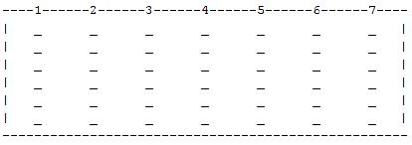

1. The board will occure with column numbers that you will enter to drop the chip in, below it there will be the player number whose turn has come
2. Each player will choose the column number to drop the chip in to get 4 consecutive same chips in a row(--),column|) ) or diagonal (either \ or / )
3. After one of the players gets 4 consecutive chips he will be the winner,

the winner is player (1 or 2) will appear

1. Finally, if youwouldlike to play again input (y) else input (n) when this statement appears

would you like to play again? (y/n) :